CPP Lecture Assignments:
// 1:write program to test Hello World.
#include<iostream>
using namespace std;
int main(){
cout<<"Hello World"<<endl;
return 0;
}
// 2:Write a program to adddition of two numbers .
#include<iostream>
using namespace std;
int main(){
int no1, no2, no3;
cout<<"No.1: "<<endl;
cin>>no1;
cout<<"No.2: "<<endl;
cin>>no2;
no3 = no1 + no2;
cout<<"Addition of two numbers is : "<<no3<<endl;
return 0;
}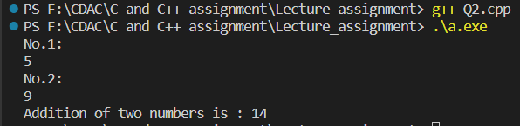
// 3:Write a program to swap two numbers.
#include<iostream>
using namespace std;
int main(){
int no1, no2;
cout<<"No.1: ";
cin>>no1;
cout<<"No.2: "<<endl;
cin>>no2;

no1 = no1 + no2;
no2 = no1 - no2;
no1 = no1 - no2;
cout<<"Swapped numbers are: "<<endl;
cout<<"No.1: "<<no1<<endl;
cout<<"No.2: "<<no2<<endl;
return 0;
}
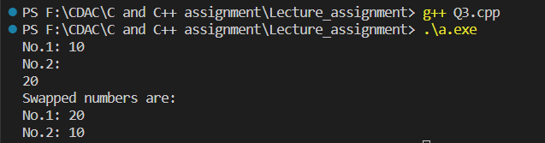

// 4. Write a program to accept an integer and check if it is even or odd.
#include<iostream>
using namespace std;

int main(){
int no;
cout<<"Enter the no.: ";
cin>>no;
if(no % 2 == 0){
cout<<"It is even."<<endl;
}
else{
cout<<"It is odd."<<endl;
}
return 0;
}
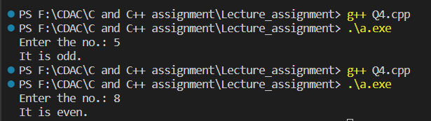

// 5. Write a program to accept a number and check if it is divisible by 5 and 7.
#include<iostream>
using namespace std;

int main(){
int no;
cout<<"Enter the number: ";
cin>>no;
if(no % 5 == 0 && no % 7 == 0){
cout<<"It is divisible by 5 and 7."<<endl;
}
else{
cout<<"Not divisible by 5 and 7."<<endl;
}
return 0;
}
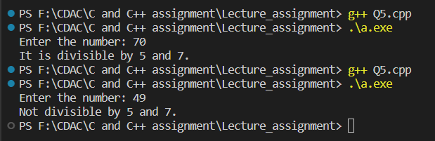

/*6. Write a program, which accepts annual basic salary of an employee and calculates and displays the Income tax as per the following rules.
Basic: < 1, 50,000 Tax = 0
1, 50,000 to 3,00,000 Tax = 20%
> 3,00,000 Tax = 30%
*/
#include<iostream>
using namespace std;

int main(){
int basic_sal;
int tax;
cout<<"Enter the salary: ";
cin>>basic_sal;

if(basic_sal < 150000){
tax = 0;
cout<<"Income tax is : "<<tax<<endl;
}
else if(basic_sal >= 150000 && basic_sal <= 300000){
tax = 20;
basic_sal = basic_sal * 0.2;
cout<<"Income tax is : "<<basic_sal<<endl;
}
else{
tax = 30;
basic_sal = basic_sal * 0.3;
cout<<"Income tax is :"<<basic_sal<<endl;
}
return 0;
}
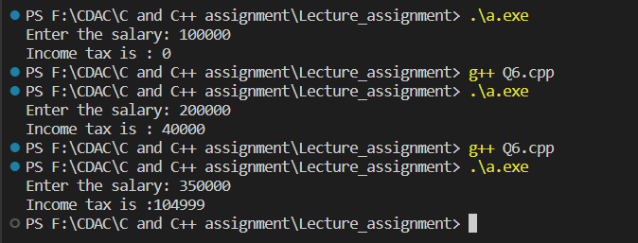

/*7. Accept a lowercase character from the user and check whether the character is a vowel or consonant.
(Hint: a, e, i, o, u are vowels)*/
#include<iostream>
using namespace std;

int main(){
char alpha;
cout<<"Enter the character: ";
cin>>alpha;

if(alpha == 'a' || alpha == 'e' || alpha == 'i' || alpha == 'o' || alpha == 'u'){
cout<<"Character is a vowel."<<endl;
}
else if(alpha >= 97 && alpha <= 122){
cout<<"Character is a consonant."<<endl;
}
else{
cout<<"It is a character."<<endl;
}
return 0;
}
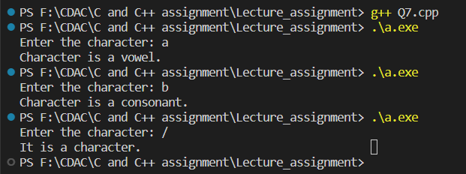

// 8. Write a program to input angles of a triangle and check whether triangle is valid or not.
#include<iostream>
using namespace std;

int main(){
int angle1, angle2, angle3, sum;
cout<<"Angle1: ";
cin>>angle1;
cout<<"\nAngle2: ";
cin>>angle2;
cout<<"\nAngle3: ";
cin>>angle3;

sum = angle1 + angle2 + angle3;
if(sum == 180){
cout<<"Triangle is valid."<<endl;
}
else{
cout<<"Triangle is invalid"<<endl;
}
return 0;
}
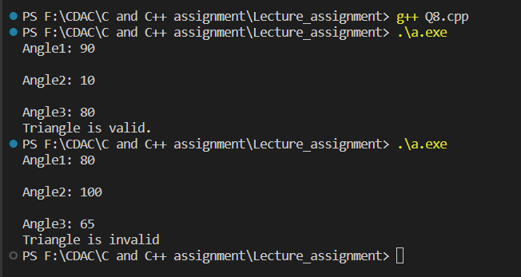

// 9:Write a program to find factorial of a given number. ex:no5 fact=5*4*3*2*1=120
#include<iostream>
using namespace std;

int main(){
int no, fact = 1;
cout<<"Enter the number: ";
cin>>no;
for (int i = 1; i <= no; i++)
{
fact = fact * i;
}
cout<<"\nFactorial of "<<no<<" is: "<<fact;
return 0;
}
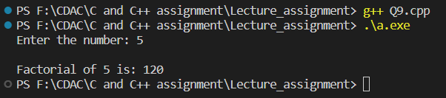

// 10:Write a program to find m to the power n. m=3 and n=4 so 3*3*3*3
#include<iostream>
using namespace std;

int main(){
int m, n, prod=1;
cout<<"Enter m value: ";
cin>>m;
cout<<"\nEnter n value: ";
cin>>n;
while(n != 0){
prod *= m;
--n;
}

cout<<prod;
return 0;
}
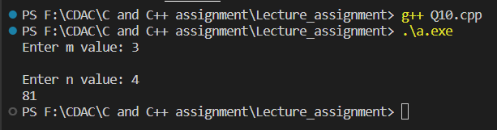

// 11:Check if number is a prime number or not.:
#include<iostream>
using namespace std;

int main(){
int no;
bool flag = true;
cout<<"Enter the no.: ";
cin>>no;

for(int i = 2; i<no; i++){
if(no % i == 0){
flag = false;
break;
}
else{
flag = true;
}
}
if(flag == true){
cout<<"\nNumber is a prime number.";
}
else{
cout<<"Number is not a prime number.";
}
return 0;
}
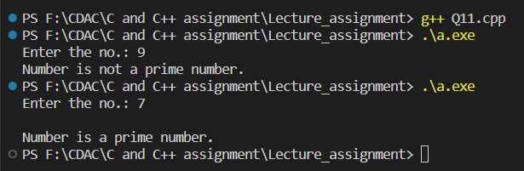

// 12:Sum of series :
// 1+2+3+….+n
#include<iostream>
using namespace std;

int main(){
int n, sum;
cout<<"Enter the number: ";
cin>>n;
sum = n * ((n+1) / 2);
cout<<"\nSum of series is: "<<sum;
return 0;
}

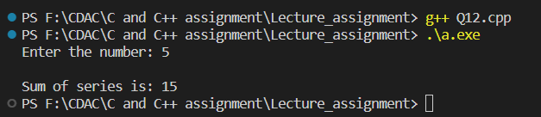

// 13:Check whether the number is palindrome or not?
#include<iostream>
using namespace std;
int main(){
int a, b, c, s=0;
cout<<"Enter the number: ";
cin>>a;
c = a;
while(a > 0){
b = a % 10;
s = (s * 10) + b;
a = a / 10;
}
if(s == c){
cout<<"\nThe number is a palindrome.";
}
else{
cout<<"The number is not a palindrome.";
}
return 0;
}
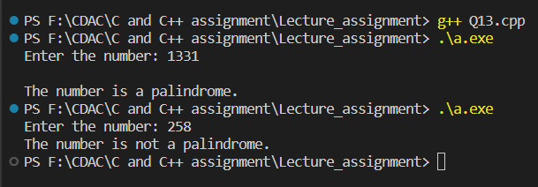

// 14:Write a program to find sum of all even and odd numbers between 1 to n.
#include<iostream>
using namespace std;
int main(){
int n, sumOdd = 0, sumEven = 0;
cout<<"Enter the number:";
cin>>n;
for(int i = 2; i<n; i++){
if(i % 2 == 0){
sumEven += i;
}
else{
sumOdd += i;
}
}
cout<<"\nSum of even numbers is: "<<sumEven;
cout<<"\nSum of odd numbers is: "<<sumOdd;
return 0;
}
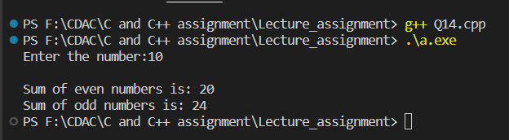
// 15: Write a program to enter a number and print its reverse.
#include<iostream>
using namespace std;
int main(){
int no, q, r;
cout<<"Enter the number: ";
cin>>no;
while(no != 0){
r = no % 10;
cout<<r;
no = no / 10;
}
return 0;
}
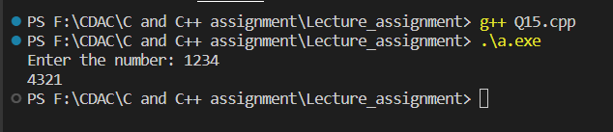

// 16:Write a program to print all Prime numbers between 1 to n.
#include<iostream>
using namespace std;

bool isPrime(int n){
if(n == 1 || n == 0){
return false;
}
for(int i = 2; i<=n/2; i++){
if(n % i == 0){
return false;
}
}
return true;
}
int main(){
int n;
cout<<"Enter the number: ";
cin>>n;
for (int i = 1; i <= n; i++)
{
if(isPrime(i)){
cout<<i<<endl;
}
}
return 0;
}
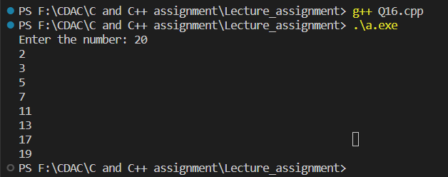

// 17:Write a program to check entered number is Armstrong number or not.
#include<iostream>
#include<cmath>
using namespace std;
int main(){
int num, orgNum, rem, n=0, result = 0, power;
cout<<"Enter the number: ";
cin>>num;
orgNum = num;

while(orgNum != 0){
orgNum /= 10;
++n;
}
orgNum = num;
while(orgNum != 0){
rem = orgNum % 10;
power = round(pow(rem, n));
result += power;
orgNum /= 10;
}
if(result == num){
cout<<num<<" is an Armstrong number.";
}
else{
cout<<num<<" is not an Armstrong number";
}
return 0;
}
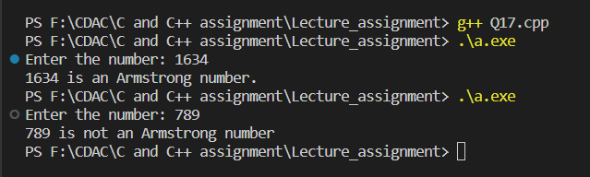
// 18:Write a program to find greatest of three numbers using nested if-else.
#include<iostream>
using namespace std;
int main(){
int no1, no2, no3;
cout<<"Enter no1.: ";
cin>>no1;
cout<<"\nEnter no2.: ";
cin>>no2;
cout<<"\nEnter no3.: ";
cin>>no3;

if(no1 > no2){
if(no1 > no3){
cout<<no1<<" is greatest."<<endl;
}
else{
cout<<no3<<" is greatest."<<endl;
}
}
else{
if(no2 > no3){
cout<<no2<<" is greatest."<<endl;
}
else{
cout<<no3<<" is greatest."<<endl;
}
}
return 0;
}
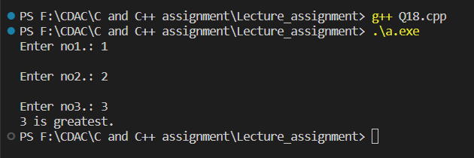

// 19:Create menu driven program for Pizza Shop.And display total amount.
#include<iostream>
using namespace std;

int main(){
int choice,total=0;
do{
cout<<"----------Pizza Menu-----------"<<endl;
cout<<"1. Mexican Pizza --> $25"<<endl;
cout<<"2. Farmhouse Pizza --> $30"<<endl;
cout<<"3. Pasta Pizza --> $20"<<endl;
cout<<"4. Pepperoni Pizza --> $22"<<endl;
cout<<"5. Paneer Pizza --> $35"<<endl;
cout<<"6. Exit"<<endl;

cout<<"Enter your choice: ";
cin>>choice;
switch (choice)
{
case 1:
total += 25;
cout<<"You chose Mexican pizza, your bill is: $"<<total<<endl;
break;
case 2:
total += 30;
cout<<"You chose Farmhouse pizza, your bill is: $"<<total<<endl;
break;
case 3:
total += 20;
cout<<"You chose Pasta pizza, your bill is: $"<<total<<endl;
break;
case 4:
total += 22;
cout<<"You chose Pepperoni pizza, your bill is: $"<<total<<endl;
break;
case 5:
total += 35;
cout<<"You chose Paneer pizza, your bill is: $"<<total<<endl;
break;
case 6:
cout<<"Your total bill is: "<<total<<endl;
break;
default:
cout<<"Invalid choice.";
break;
}
}while(choice != 6);
return 0;
}
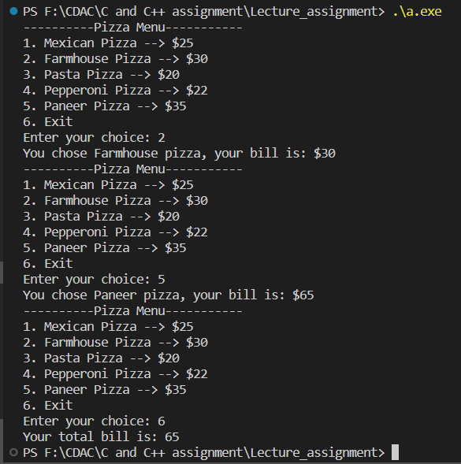

// 20:Accept a single digit from the user and display it in words. For example, if digit entered is 9, display Nine.
#include<iostream>
using namespace std;

int main(){
int digit;
cout<<"Enter the digit: ";
cin>>digit;
switch (digit)
{
case 0:
cout<<"Zero"<<endl;
break;
case 1:
cout<<"One"<<endl;
break;
case 2:
cout<<"Two"<<endl;
break;
case 3:
cout<<"Three"<<endl;
break;
case 4:
cout<<"Four"<<endl;
break;
case 5:
cout<<"Five"<<endl;
break;
case 6:
cout<<"Six"<<endl;
break;
case 7:
cout<<"Seven"<<endl;
break;
case 8:
cout<<"Eight"<<endl;
break;
case 9:
cout<<"Nine"<<endl;
break;
default:
cout<<"Invalid choice"<<endl;
break;
}
return 0;
}
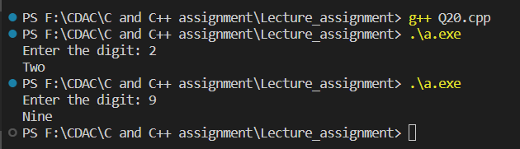

/*21. Write a program, which accepts two integers and an operator as a character (+ - * / ), performs the corresponding operation and displays the result.*/
#include<iostream>
using namespace std;

int main(){
int no1, no2, result;
char opr;

cout<<"Enter no1: ";
cin>>no1;
cout<<"\nEnter no2: ";
cin>>no2;
cout<<"\nEnter the operator: ";
cin>>opr;
switch (opr)
{
case '+':
result = no1 + no2;
cout<<"Result: "<<result;
break;
case '-':
result = no1 - no2;
cout<<"Result: "<<result;
break;
case '*':
result = no1 * no2;
cout<<"Result: "<<result;
break;
case '/':
result = no1 / no2;
cout<<"Result: "<<result;
break;
default:
cout<<"Invalid choice.";
break;
}
return 0;
}
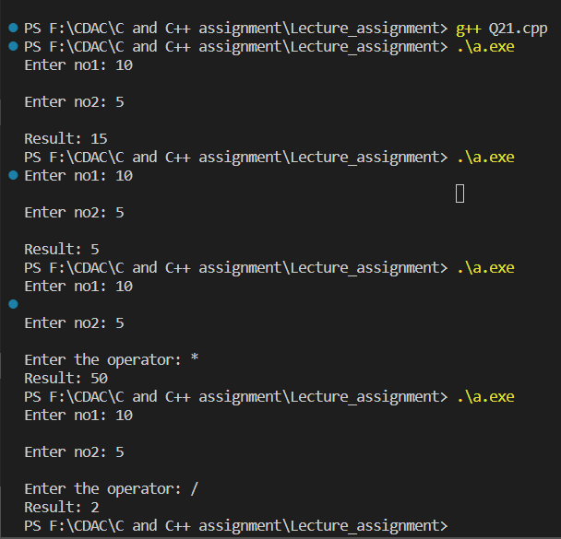

CPP Lecture Assignments 2:
/*1:Write a program that accepts numbers continuously as long as the number is positive and prints the sum of the given numbers. */
#include<iostream>
using namespace std;
int main(){
int n, sum=0;
do
{
cout<<"Enter the number: ";
cin>>n;
if(n<0){
break;
}
else{
sum += n;
cout<<"Sum is: "<<sum<<endl;
}
} while (n > 0);
return 0;
}
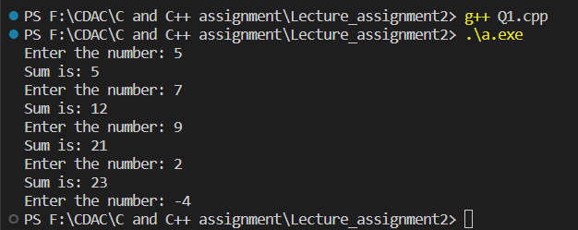

// 2. Write a program to accept two integers x and n and compute x raised to n.
#include<iostream>
using namespace std;
int main(){
int x, n, prod = 1, temp;
cout<<"Enter x value: ";
cin>>x;
cout<<"\nEnter n value: "<<endl;
cin>>n;
temp = n;
while(n != 0){
prod *= x;
--n;
}
cout<<x<<" raised to "<<temp<<" is: "<<prod<<endl;;
return 0;
}
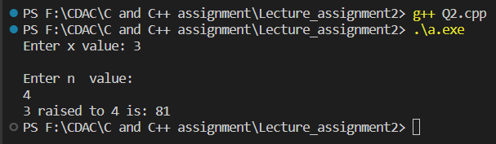

// 3. Write a program to accept a character, an integer n and display the next n characters.
#include<iostream>
using namespace std;
int main(){
int n;
char ch;
cout<<"Enter the character: ";
cin>>ch;
cout<<"\nEnter the n value: ";
cin>>n;
ch++;
while (n != 0)
{
cout<<ch<<endl;
ch++;
n--;
}
return 0;
}
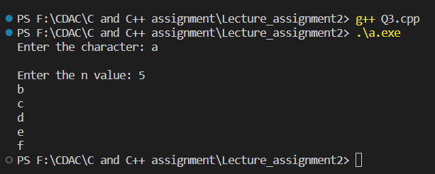

/*4. Write a program to calculate factorial of a number. For e.g. factorial of 5 = 5! = 5 *4*3*2*1 = 120*/
#include<iostream>
using namespace std;
int fact(int n){
if(n == 0){
return 1;
}
else{
return n * fact(n-1);
}
}
int main(){
int no;
cout<<"Enter the no.: ";
cin>>no;
cout<<"Factorial of "<<no<<" is "<<fact(no)<<endl;
return 0;
}
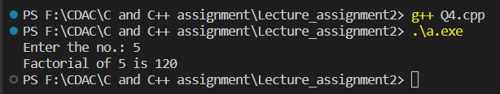

// 5. Write a program to calculate factors of a given number.
#include<iostream>
using namespace std;

int main(){
int no, factor;
cout<<"Enter the no.: ";
cin>>no;
cout<<"\nFactors of "<<no<<" are :";
for(int i=1; i<=no; i++){
if(no % i == 0){
cout<<i<<" ";
}
}
return 0;
}
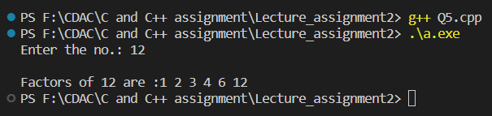

// 6. Accept two numbers and calculate GCD of them.
#include<iostream>
using namespace std;

int main(){
int no1, no2, gcd;
cout<<"Enter no1.: ";
cin>>no1;
cout<<"\nEnter no2.: ";
cin>>no2;
for(int i = 1; i <= no1 && i <= no2; i++){
if(no1 % i == 0 && no2 % i == 0){
gcd = i;
}
}
cout<<"GCD of "<<no1<<" and "<<no2<<" is "<<gcd;
return 0;
}
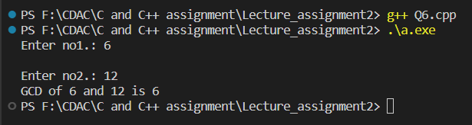
/*7. Write a menu driven program to do following operations :
a) Compute area of circle
b) Compute area of rectangle
c) Compute area of triangle
d) Exit
Display menu, ask choice to the user, depending on choice accept the parameters and perform the operation. Continue this process until user selects exit option.
*/
#include<iostream>
using namespace std;

int main(){
int radius, length, breadth, base, height, choice;
float area;
do{
cout<<"1. Compute area of circle."<<endl;
cout<<"2. Compute area of rectangle."<<endl;
cout<<"3. Compute area of triangle."<<endl;
cout<<"4. Exit"<<endl;
cout<<"Enter your choice: ";
cin>>choice;
switch (choice)
{
case 1:
cout<<"\nEnter radius of circle: ";
cin>>radius;
area = 3.14 * radius * radius;
cout<<"\nArea of circle is: "<<area<<endl;
break;
case 2:
cout<<"\nEnter length of rectangle: ";
cin>>length;
cout<<"\nEnter breadth of rectangle: ";
cin>>breadth;
area = length * breadth;
cout<<"\nArea of rectangle is: "<<area<<endl;
break;
case 3:
cout<<"\nEnter base of triangle: ";
cin>>base;
cout<<"\nEnter height of triangle: ";
cin>>height;
area = 0.5 * base * height;
cout<<"\nArea of triangle is: "<<area<<endl;
break;
case 4:
cout<<"Exit"<<endl;
break;
default:
cout<<"Invalid choice"<<endl;
break;
}
}while(choice != 4);
return 0;
}
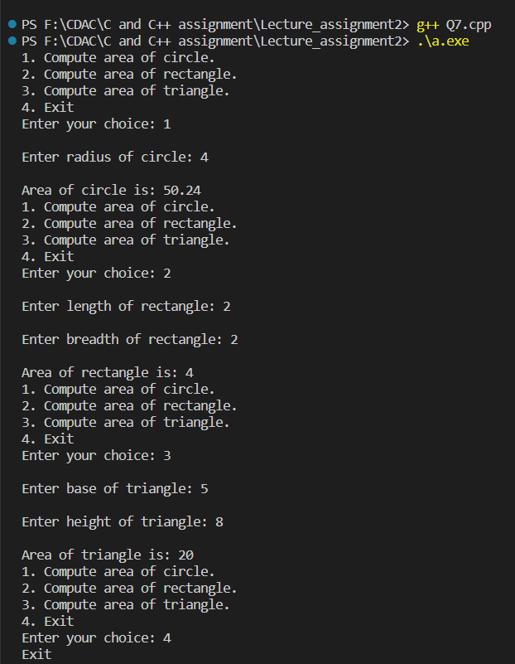

// 8. Write a program to print all prime numbers between 1 to n
#include<iostream>
using namespace std;

bool isPrime(int n){
if(n == 1 || n == 0){
return false;
}
for(int i = 2; i<=n/2; i++){
if(n % i == 0){
return false;
}
}
return true;
}
int main(){
int n;
cout<<"Enter the number: ";
cin>>n;
for (int i = 1; i <= n; i++)
{
if(isPrime(i)){
cout<<i<<endl;
}
}
return 0;
}
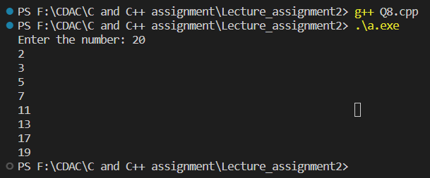

CPP Lecture Assignment 3:
/*1:Write a program to create student class with data members rollno, marks1,mark2,mark3.
Accept data (acceptInfo()) and display using display member function. Also display total,percentage and grade.*/
#include<iostream>
using namespace std;
class Student{
private:
int rollno, marks1, marks2, marks3;
int total;
double percentage;
char grade;
public:
void acceptInfo(){
cout<<"Enter roll no.: ";
cin>>rollno;
cout<<"\nEnter marks1: ";
cin>>marks1;
cout<<"\nEnter marks2: ";
cin>>marks2;
cout<<"\nEnter marks3: ";
cin>>marks3;
}
void displayInfo(){
cout<<"Roll No.: "<<rollno;
cout<<"\nMarks1: "<<marks1;
cout<<"\nMarks2: "<<marks2;
cout<<"\nMarks3: "<<marks3;
cout<<"\n Total: "<<total;
cout<<"\n Percentage: "<<percentage;
cout<<"\n Grade: "<<grade;
}
void calTotal(){
total = marks1 + marks2 + marks3;
}
void calPercentage(){
percentage = total / 300.00;
percentage = percentage * 100.00;
}
void calGrade(){
if(percentage > 90){
grade = 'A';
}
else if(percentage > 80 && percentage < 90){
grade = 'B';
}
else if(percentage > 70 && percentage < 80){
grade = 'C';
}
else if(percentage > 60 && percentage < 70){
grade = 'D';
}
}
};
int main(){
Student stdObj;
stdObj.acceptInfo();
stdObj.calTotal();
stdObj.calPercentage();
stdObj.calGrade();
stdObj.displayInfo();
return 0;
}
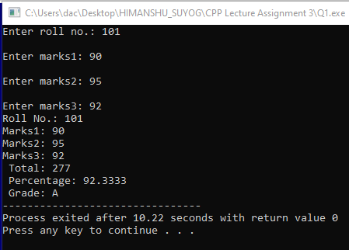

//2. Create a class Person with data members as name, age, city. Also add accept and display function. . Create the object of this class in main method and invoke all the methods in that class.
#include<iostream>
using namespace std;
class Person{
private:
string name;
int age;
string city;
public:
void displayInfo(){
cout<<"Person name is: "<<name;
cout<<"\nPerson age: "<<age;
cout<<"\nCity: "<<city;
}
void acceptInfo(){
cout<<"Enter person name: ";
cin>>name;
cout<<"\nEnter age: ";
cin>>age;
cout<<"\nEnter city: "<<endl;
cin>>city;
}
};
int main(){
Person p;
p.acceptInfo();
p.displayInfo();
return 0;
}
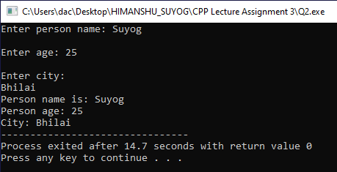

/*3. Create a class Date with data members as dd, mm, yy. Create AcceptDate function. Also add the display function.
Create the object of this class in main method and invoke all the methods in that class.*/
#include<iostream>
using namespace std;
class Date{
private:
int dd;
int mm;
int yy;
public:
void acceptDate(){
cout<<"Enter date: ";
cin>>dd;
cout<<"\nEnter month: ";
cin>>mm;
cout<<"\nEnter year: ";
cin>>yy;
}
void displayDate(){
cout<<"\nDate is: "<<dd<<"/"<<mm<<"/"<<yy;
}
};
int main(){
Date today;
today.acceptDate();
today.displayDate();
return 0;
}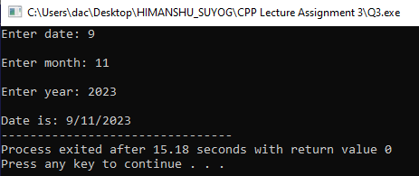
/*3. Create a class Book with data members as bname,id,author,price. Write AcceptBook function . Also add the display function. Create Default and Parameterized constructors. Create the object of this class in main method and invoke all the methods in that class.*/
#include<iostream>
using namespace std;
class Book{
private:
int id;
string name;
string author;
int price;
public:
void acceptBook(){
cout<<"Enter id: ";
cin>>id;
cout<<"\nEnter name: ";
cin>>name;
cout<<"\nEnter author: ";
cin>>author;
cout<<"\nEnter price: ";
cin>>price;
}
void displayBook(){
cout<<"\nBook id: "<<id<<" with name "<<name<<" who's author is "<<author<<" is priced at "<<"$"<<price; }
};
int main(){
Book b;
b.acceptBook();
b.displayBook();
return 0;
}
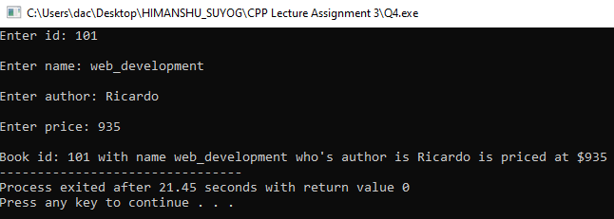

/*4. Create a class Point with data members as x,y. Add AcceptPoint and add the display function. Create the object of this class in main method and invoke all the methods in that class.*/
#include<iostream>
using namespace std;
class Point{
private:
int x, y;
public:
void acceptPoint(){
cout<<"Enter point x: ";
cin>>x;
cout<<"Enter point y: ";
cin>>y;
}
void displayPoint(){
cout<<"\nPoint is x: "<<x<<" and y is: "<<y;
}
};
int main(){
Point p;
p.acceptPoint();
p.displayPoint();
return 0;
}
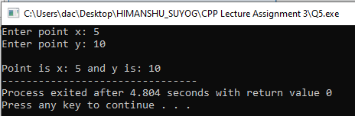

/*5. Create a class ComplexNumber with data members real, imaginary. Create AcceptComplexNumber() and the display function. Create the object of this class in main method and invoke all the methods in that class.*/
#include<iostream>
using namespace std;
class ComplexNumber{
private:
int real;
int imaginary;
public:
void acceptComplexNumber(){
cout<<"Enter real no.: ";
cin>>real;
cout<<"\nEnter complex no.: ";
cin>>imaginary;
}
void displayComplexNumber(){
cout<<"\nComplex number is: "<<real<<" + "<<imaginary<<"i";
}
};
int main(){
ComplexNumber complex;
complex.acceptComplexNumber();
complex.displayComplexNumber();
return 0;
}
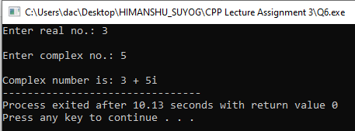
CPP Lecture Assignment 4:
/*1:Write a program to create student class with data members rollno, marks1,mark2,mark3.Accept data (acceptInfo()) and display using display member function.Also display total,percentage and grade.*/
#include<iostream>
using namespace std;
class Student{
private:
int rollno, marks1, marks2, marks3;
int total;
double percentage;
char grade;
public:
void acceptInfo(){
cout<<"Enter roll no.: ";
cin>>rollno;
cout<<"\nEnter marks1: ";
cin>>marks1;
cout<<"\nEnter marks2: ";
cin>>marks2;
cout<<"\nEnter marks3: ";
cin>>marks3;
}
void displayInfo(){
cout<<"Roll No.: "<<rollno;
cout<<"\nMarks1: "<<marks1;
cout<<"\nMarks2: "<<marks2;
cout<<"\nMarks3: "<<marks3;
cout<<"\n Total: "<<total;
cout<<"\n Percentage: "<<percentage;
cout<<"\n Grade: "<<grade;
}
void calTotal(){
total = marks1 + marks2 + marks3;
}
void calPercentage(){
percentage = total / 300.00;
percentage = percentage * 100.00;
}
void calGrade(){
if(percentage > 90){
grade = 'A';
}
else if(percentage > 80 && percentage < 90){
grade = 'B';
}
else if(percentage > 70 && percentage < 80){
grade = 'C';
}
else if(percentage > 60 && percentage < 70){
grade = 'D';
}
}
};
int main(){
Student stdObj;
stdObj.acceptInfo();
stdObj.calTotal();
stdObj.calPercentage();
stdObj.calGrade();
stdObj.displayInfo();
return 0;
}

/*2. Create a class Person with data members as name, age, city. Write getters and setters for all the data members. Also add the display function. Create Default and Parameterized constructors. Create the object of this class in main method and invoke all the methods in that class. */
#include<iostream>
#include<string>
using namespace std;
class Person
{
private:
string name;
int age;
string city;

public:
Person()
{
cout << "----default constr.-----" << endl;
name = "Ram";
age = 2;
city = "anonymous";
}
Person(string name, int age, string city)
{
cout << "--------parameterised constr.---------" << endl;
this->name = name;
this->age = age;
this->city = city;
}
void setName(string name)
{
this->name = name;
}
void setCity(string city)
{
this->city = city;
}
void setAge(int age)
{
this->age = age;
}
string getName()
{
return name;
}
int getAge()
{
return age;
}
string getCity()
{
return city;
}
void display()
{
cout<<"Name: "<<name<<"Age: "<<age<<" City :"<<city<<endl;
}
};
int main()
{
Person p;
p.setName("Suyog");
p.setAge(25);
p.setCity("Bhilai");
p.getName();
p.getAge();
p.getCity();
p.display();
Person p2("Rohan", 30, "Bhopal");
p2.display();
Person p3;
cout<<"Name: "<<p3.getName()<<" Age: "<<p3.getAge()<<"City: "<<p3.getCity()<<endl;
return 0;
}
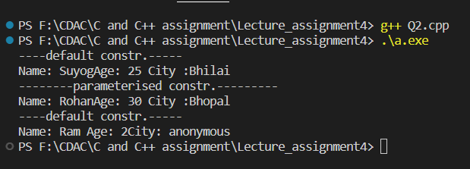

/*2. Create a class Date with data members as dd, mm, yy. Write getters and setters for all the data members. Also add the display function. Create Default and Parameterized constructors. Create the object of this class in main method and invoke all the methods in that class.*/
#include<iostream>
using namespace std;
class Date{
private:
int day, month, year;
public:
Date(){
cout<<"----default----"<<endl;
day = 1;
month = 11;
year = 1200;
}
Date(int day, int month, int year){
cout<<"------parameterised------"<<endl;
this->day = day;
this->month = month;
this->year = year;
}
void setDay(int day){
this->day = day;
}
void setMonth(int month){
this->month = month;
}
void setYear(int year){
this->year = year;
}
int getDay(){
return day;
}
int getMonth(){
return month;
}
int getYear(){
return year;
}
void display(){
cout<<"\nDate: "<<day<<"/"<<month<<"/"<<year<<endl;
}
};
int main(){
Date d1;
d1.display();
Date d2(12, 9, 2023);
d2.display();
Date d3;
d3.setDay(12);
d3.setMonth(9);
d3.setYear(2023);
d3.display();
Date d4;
int d, m, y;
cout<<"Day: ";
cin>>d;
d4.setDay(d);
cout<<"\nMonth: ";
cin>>m;
d4.setMonth(m);
cout<<"\nYear: ";
cin>>y;
d4.setYear(y);
cout<<"\nDate: "<<d4.getDay()<<"/"<<d4.getMonth()<<"/"<<d4.getYear()<<endl;
return 0;
}
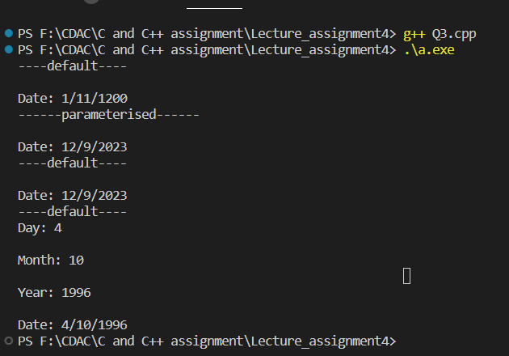

/*3. Create a class Book with data members as bname,id,author,price. Write getters and setters for all the data members. Also add the display function. Create Default and Parameterized constructors. Create the object of this class in main method and invoke all the methods in that class.*/
#include<iostream>
#include<string>
using namespace std;
class Book{
private:
string bname, author;
int id, price;
public:
Book(){
cout<<"-----default-----"<<endl;
bname = "Thermodynamics";
author = "Naveen";
id = 404;
price = 500;
}
Book(string bname, string author, int id, int price){
cout<<"------parameterised-------"<<endl;
this->bname = bname;
this->author = author;
this->id = id;
this->price = price;
}
void setId(int id){
this->id = id;
}
void setBname(string bname){
this->bname = bname;
}
void setAuthor(string author){
this->author = author;
}
void setPrice(int price){
this->price = price;
}
string getBname(){
return bname;
}
int getId(){
return id;
}
string getAuthor(){
return author;
}
int getPrice(){
return price;
}
void display(){
cout<<"\nBook: "<<bname<<" author: "<<author<<" id: "<<id<<" price: "<<price<<endl;
}
};
int main(){
Book b1;
b1.display();
Book b2("Let_us_C", "Yashwant_Kanitkar", 101, 435);
b2.display();
Book b3;
b3.setBname("Computer_Fundamentals");
b3.setAuthor("Pradeep_Sinha");
b3.setId(202);
b3.setPrice(935);
b3.display();
string bname, author;
int id, price;
cout<<"\nEnter name, author, id and price of book"<<endl;
cin >> bname >> author >> id >> price;
Book b4(bname, author, id, price);
b4.display();
return 0;
}
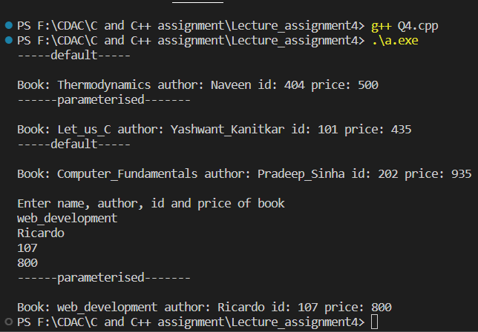

/*4. Create a class Point with data members as x,y. Create Default and Parameterized constructors. Write getters and setters for all the data members. Also add the display function. Create the object of this class in main method and invoke all the methods in that class.*/
#include<iostream>
#include<string>
using namespace std;
class Point{
private:
int x, y;
public:
Point(){
cout<<"-----default-----"<<endl;
x = 1;
y = 1;
}
Point(int x, int y){
cout<<"------parameterised-------"<<endl;
this->x = x;
this->y = y;
}
void setX(int x){
this->x = x;
}
void setY(int y){
this->y = y;
}
int getX(){
return x;
}
int getY(){
return y;
}
void display(){
cout<<"\nPoint is: \n"<<"X: "<<x<<" Y:"<<y<<endl;
}
};
int main(){
Point p1;
p1.display();
Point p2(50, 20);
p2.display();
Point p3;
p3.setX(80);
p3.setY(10);
p3.display();
int x, y;
cout<<"\nEnter point x and y: "<<endl;
cin >> x >> y;
Point p4(x, y);
p4.display();
return 0;
}

/*5. Create a class ComplexNumber with data members real, imaginary. Create Default and Parameterized constructors. Write getters and setters for all the data members. Also add the display function. Create the object of this class in main method and invoke all the methods in that class.*/
#include<iostream>
#include<string>
using namespace std;
class ComplexNumber{
private:
int real, imaginary;
public:
ComplexNumber(){
cout<<"-----default-----"<<endl;
real = 1;
imaginary = 1;
}
ComplexNumber(int real, int imaginary){
cout<<"------parameterised-------"<<endl;
this->real = real;
this->imaginary = imaginary;
}
void setReal(int real){
this->real = real;
}
void setImaginary(int imaginary){
this->imaginary = imaginary;
}
int getReal(){
return real;
}
int getImaginary(){
return imaginary;
}
void display(){
cout<<"Complex number is: "<<real<<" + "<<imaginary<<"i"<<endl;
}
};
int main(){
ComplexNumber c1;
c1.display();
ComplexNumber c2(7, 3);
c2.display();
ComplexNumber c3;
c3.setReal(8);
c3.setImaginary(1);
c3.display();
int real, imaginary;
cout<<"\nEnter real and imaginary value: "<<endl;
cin >> real >> imaginary;
ComplexNumber c4(real, imaginary);
c4.display();
return 0;
}
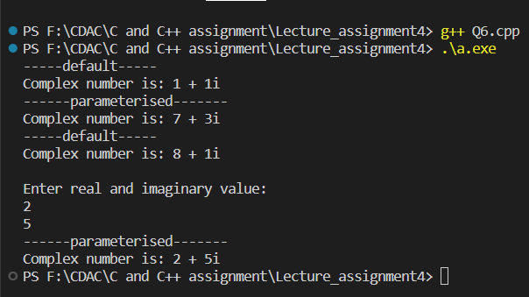
/*1:Create Date class with members day,month ,year. Write no argument and parameterised constructor .Create two object s and initialize them using no argument and parameterised constructor respectively.Print date using display function.*/
#include<iostream>
using namespace std;
class Date{
private:
int day, month, year;
public:
Date(){
day = 1;
month = 1;
year = 1000;
}
Date(int day, int month, int year){
this->day = day;
this->month = month;
this->year = year;
}
void display(){
cout<<"Date: "<<day<<"/"<<month<<"/"<<year<<endl;
}
};
int main(){
Date d1;
d1.display();
Date d2(14, 9, 2023);
d2.display();
return 0;
}
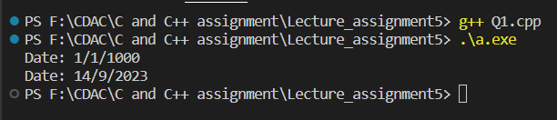
/*2:Create Employee class with members id(int),name(string),dob(Date).Use above created Date class. Write default and parameterised constructor in Employee Class.Write accept() function to accept information and display() to display emp information.*/
#include<iostream>
#include<string>
using namespace std;
class Date{
private:
int day, month, year;
public:
Date(){
day = 1;
month = 1;
year = 1000;
}
Date(int day, int month, int year){
this->day = day;
this->month = month;
this->year = year;
}
void acceptDate(){
cout<<"Enter day: ";
cin>>day;
cout<<"\nEnter month: "<<endl;
cin>>month;
cout<<"\nEnter year: "<<endl;
cin>>year;
}
void displayInfo(){
cout<<"Date: "<<day<<"/"<<month<<"/"<<year<<endl;
}
};
class Employee : public Date{
private:
int id;
string name;
public:
Employee(){
id = 101;
name = "Ram";
}
Employee(int id, string name){
this->id = id;
this->name = name;
}
void acceptInfo(){
cout<<"Enter id: ";
cin>>id;
cout<<"\nEnter name: ";
cin>>name;
Date::acceptDate();
}
void display(){
cout<<"\nId: "<<id<<" name: "<<name<<endl;
Date::displayInfo();
}
};
int main(){
Employee emp;
emp.display();
Employee emp2(201, "Suyog");
emp2.display();
Employee emp3;
emp3.acceptInfo();
emp3.display();
return 0;
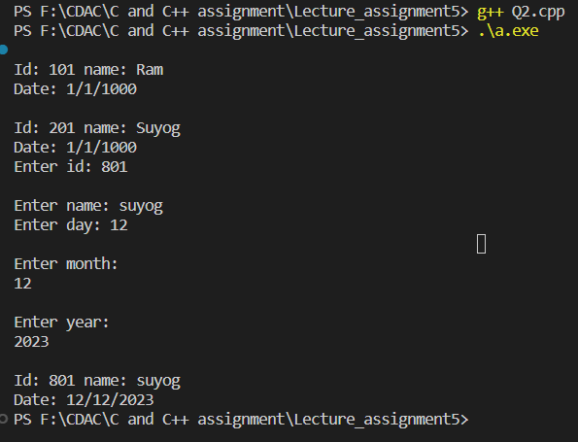
/*3:Consider that payroll software needs to be developed for computerization of operations of an ABC organization. The organization has employees.
3.1. Construct a class Employee with following members using private access specifies:
Employee Id integer
Employee Name string
Basic Salary double
HRA double
Medical double=1000
PF double
PT double
Net Salary double
Gross Salary double
Please use following expressions for calculations://Note:Don't accept HRA,PF PT from user
* HRA = 50% of Basic Salary
* PF = 12% of Basic Salary
* PT = Rs. 200

3.2. Write methods to display the details of an employee and calculate the gross
and net salary.
* Goss Salary = Basic Salary + HRA + Medical
* Net Salary = Gross Salary – (PT + PF)
Create Object of employee class and assign values and display Details.
*/
#include <iostream>
#include<string>
using namespace std;
class Employee
{
private:
int id;
string name;
double basic_salary, HRA, medical, PF, PT, net_salary, gross_salary;
public:
Employee()
{
id = 101;
name = "Ram";
basic_salary = 10;
HRA = 10;
medical = 1000;
PF = 10;
PT = 10;
gross_salary = 100;
net_salary = 100;
}
Employee(int id, string name, int basic_salary, int medical)
{
this->id = id;
this->name = name;
this->basic_salary = basic_salary;
// this->HRA = HRA;
this->medical = medical;
// this->PF = PF;
// this->PT = PT;
}
void calHRA()
{
HRA = 0.5 * basic_salary;
}
void calPF()
{
PF = 0.12 * basic_salary;
}
void calPT()
{
PT = 200;
}
void calGrossSalary(){
gross_salary = basic_salary + HRA + medical;
}
void netSalary(){
net_salary = gross_salary - (PT + PF);
}
void display(){
cout<<"Id: "<<id<<" Name: "<<name<<" Basic salary: "<<basic_salary<<" medical: "<<medical<<" \nPF: "<<PF<<" HRA: "<<HRA<<" PT: "<<PT<<" Gross salary: "<<gross_salary<<" Net salary "<<net_salary<<endl;
}
};
int main(){
Employee emp;
emp.display();
Employee emp2(202, "Suyog", 20000, 1000);
emp2.calHRA();
emp2.calPF();
emp2.calPT();
emp2.calGrossSalary();
emp2.netSalary();
emp2.display();
return 0;
}
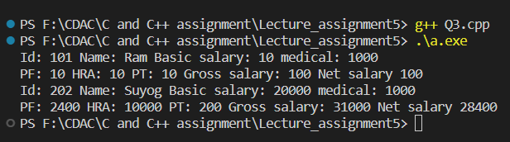
/*Solve this.
Fresh business scenario to apply inheritance , polymorphism to emp based organization scenario.
Create Emp based organization structure --- Emp , Mgr , Worker
1.1 Emp state--- id(int), name, deptId , basicSalary(double)
Accept all of above in constructor arguments.
Methods ---
1.2. compute net salary ---ret 0
(eg : public double computeNetSalary(){return 0;})
1.2 Mgr state ---id,name,basic,deptId , perfBonus
Add suitable constructor
Methods ----
1. compute net salary (formula: basic+perfBonus) -- override computeNetSalary
1.3 Worker state --id,name,basic,deptId,hoursWorked,hourlyRate
Methods :
1. compute net salary (formula: = basic+(hoursWorked*hourlyRate) --override computeNetSalary
2. get hrlyRate of the worker -- add a new method to return hourly rate of a worker.(getter)
Create suitable array to store organization details.
Provide following options
1. Hire Manager
I/P : all manager details
2. Hire Worker
I/P : all worker details
3. Display information of all employees net salary (by invoking computeNetSal),
4. Exit
*/
#include<iostream>
#include<vector>
#include<string>
using namespace std;
class Employee{
protected:
int id;
string name;
int deptId;
double basicSalary;
public:
Employee(int id, string name, int deptId, double basicSlary){
this->id = id;
this->name = name;
this->deptId = deptId;
this->basicSalary = basicSalary;
}
virtual double computeSalary(){
return 0;
}
};
class Manager : public Employee{
private:
int id;
string name;
int deptId;
double basicSalary;
double perfBonus;
public:
Manager(int id, string name, int deptId, double basicSalary, double perfBonus) : Employee(id, name, deptId, basicSalary){
this->id = id;
this->name = name;
this->deptId = deptId;
this->basicSalary = basicSalary;
this->perfBonus = perfBonus;
}
double computeSalary(){
return basicSalary + perfBonus;
}
};
class Worker : public Employee{
private:
int id;
string name;
int deptId;
double basicSalary;
double perfBonus;
double hoursWorked;
double hourlyRate;
public:
Worker(int id, string name, int deptId, double basicSalary, double hoursWorked, double hourlyRate) : Employee(id, name, deptId, basicSalary){
this->id = id;
this->name = name;
this->deptId = deptId;
this->basicSalary = basicSalary;
this->perfBonus = perfBonus;
this->hourlyRate = hourlyRate;
this->hoursWorked = hoursWorked;
}
double computeSalary(){
return basicSalary + (hoursWorked * hourlyRate);
}
double getHourlyRate(){
return hourlyRate;
}
};
int main(){
vector<Employee*> employees;
while(true){
cout << "Menu:" << endl;
cout << "1. Hire Manager" << endl;
cout << "2. Hire Worker" << endl;
cout << "3. Display information of all employees' net salary" << endl;
cout << "4. Exit" << endl;
cout << "Enter your choice: ";
int choice;
cin >> choice;
switch(choice){
case 1:
cout << "Hiring a Manager:" << endl;
int mgrId;
string mgrName;
int mgrDeptId;
double mgrBasicSalary;
double perfBonus;
cout << "Enter ID: ";
cin >> mgrId;
cout << "Enter Name: ";
cin >> mgrName;
cout << "Enter Department ID: ";
cin >> mgrDeptId;
cout << "Enter Basic Salary: ";
cin >> mgrBasicSalary;
cout << "Enter Performance Bonus: ";
cin >> perfBonus;
Manager* mgr = new Manager(mgrId, mgrName, mgrDeptId, mgrDeptId, mgrBasicSalary, perfBonus);
employees.push_back(mgr);

cout << "Manager hired successfully!" << endl;
break;
case 2:
cout << "Hiring a Worker:" << endl;
int workerId;
string workerName;
int workerDeptId;
double workerBasicSalary;
double hoursWorked;
double hourlyRate;
cout << "Enter ID: ";
cin >> workerId;
cout << "Enter Name: ";
cin >> workerName;
cout << "Enter Department ID: ";
cin >> workerDeptId;
cout << "Enter Basic Salary: ";
cin >> workerBasicSalary;
cout << "Enter Hours Worked: ";
cin >> hoursWorked;
cout << "Enter Hourly Rate: ";
cin >> hourlyRate;
Worker* wrk = new Worker(workerId, workerName, workerDeptId, workerBasicSalary, hoursWorked, hourlyRate);

employees.push_back(wrk);
cout << "Worker hired successfully!" << endl;
break;
case 3:
cout << "Employee Information:" << endl;
for (Employee* emp : employees) {
cout << "ID: " << emp->id << endl;
cout << "Name: " << emp->name << endl;
cout << "Department ID: " << emp->deptId << endl;
cout << "Net Salary: " << emp->computeSalary() << endl;
if (Worker* workerEmp = dynamic_cast<Worker*>(emp)) {
cout << "Hourly Rate: " << workerEmp->getHourlyRate() << endl;
}
cout << endl;
}
break;
case 4:
for (Employee* emp : employees) {
delete emp; // Free allocated memory
}
cout << "Exiting the program." << endl;
break;
default:
cout << "Invalid choice. Please try again." << endl;
break;
}
}
return 0;
}
/*2:Create cpp application for bank account handling.
2.1. Create a class BankAccount -- acct no(int),customer name(string),balance(double)
Add constr. (2 constrs : first to accept all details )

2.2 Add Business logic methods
Methods
public void withdraw(double amt)
public void deposit(double amt)

2.3: Create object of account class and test withdraw and deposit methods.
*/
#include <iostream>
#include <string>

using namespace std;

class BankAccount {
private:
int accountNumber;
string customerName;
double balance;

public:
// Constructor to initialize account details
BankAccount(int acctNo, string name, double initialBalance) {
accountNumber = acctNo;
customerName = name;
balance = initialBalance;
}

// Method to withdraw money from the account
void withdraw(double amount) {
if (amount > 0 && amount <= balance) {
balance -= amount;
cout << "Withdrawal of $" << amount << " successful." << endl;
} else {
cout << "Withdrawal failed. Insufficient balance." << endl;
}
}

// Method to deposit money into the account
void deposit(double amount) {
if (amount > 0) {
balance += amount;
cout << "Deposit of $" << amount << " successful." << endl;
} else {
cout << "Deposit failed. Invalid amount." << endl;
}
}

// Method to display account details
void displayAccountDetails() {
cout << "Account Number: " << accountNumber << endl;
cout << "Customer Name: " << customerName << endl;
cout << "Balance: $" << balance << endl;
}
};

int main() {
// Create a BankAccount object with initial details
BankAccount myAccount(12345, "Suyog Ghate", 1000.0);

// Display initial account details
cout << "Initial Account Details:" << endl;
myAccount.displayAccountDetails();

// Test withdrawal and deposit methods
myAccount.withdraw(500.0);
myAccount.deposit(200.0);

// Display updated account details
cout << "\nUpdated Account Details:" << endl;
myAccount.displayAccountDetails();

return 0;
}

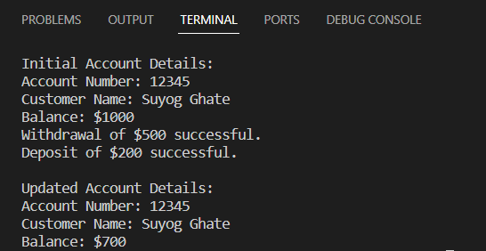
/*3:Create a abstract class Shape with pure virtual method area;
Create Rectangle,Circle,Square class..inherit them from Shape class..Override area method.
Test these all classes by creating object of respective class.*/

#include<iostream>
#include<math.h>
using namespace std;

class Shape{
protected:
double area, perimeter;
public:
virtual void calArea() = 0;
virtual void display() = 0;
};

class Circle : public Shape{
private:
int radius;
public:
Circle(int radius){
this->radius = radius;
}

void calArea(){
area = 3.14 * radius * radius;
}

void display(){
cout<<"\nArea of circle: "<<this->area;
}
};

class Rectangle : public Shape{
private:
int length, breadth;
public:
Rectangle(int length, int breadth){
this->length = length;
this->breadth = breadth;
}

void calArea(){
area = length * breadth;
}

void display(){
cout<<"\nArea of rectangle: "<<this->area;
}
};

class Triangle : public Shape{
private:
int side1, side2, side3;
public:
Triangle(int side1, int side2, int side3){
this->side1 = side1;
this->side2 = side2;
this->side3 = side3;
}

void calArea(){
double s = (side1 + side2 + side3) / 2.0;
area = sqrt(s * (s - side1) * (s - side2) * (s - side3));
}

void display(){
cout<<"\nArea of triangle: "<<this->area;
}
};

int main(){
Circle circle(5);
circle.calArea();
circle.display();

Rectangle rectangle(5, 8);
rectangle.calArea();
rectangle.display();

Triangle triangle(3, 4, 5);
triangle.calArea();
triangle.display();

return 0;
}
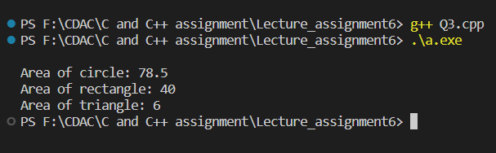
/*1:Create class for Handling Exception for Student
Create StudentException class;
Create Student class with data members (rollno,name,age)
at the time of student creation check age if age<18 then throw exception
*/

#include<iostream>
#include<string>
using namespace std;

class StudentException{
public:
const char *message;
public:
StudentException(){}
StudentException(const char *message){
this->message = message;
}
};

class Student : public StudentException{
int rollno, age;
string name;
public:
Student(int rollno, int age, string name){
this->rollno = rollno;
this->age = age;
this->name = name;

if(age < 18){
throw StudentException("Student is not allowed to go to picnic...");
}
}

void display(){
cout<<"Roll no.: "<<rollno<<endl;
cout<<"Name: "<<name<<endl;
cout<<"Age: "<<age<<endl;
}
};

int main(){
try{
Student st1(101, 25, "Suyog");
st1.display();

Student st2(102, 15, "Rohit");
st2.display();
}
catch(const StudentException &m){
cout<<"Exception: "<<m.message<<endl;
}
return 0;
}
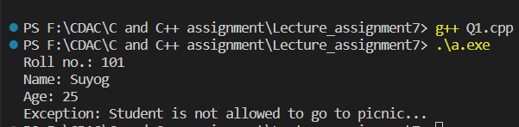
// 2:Create Function Template and class template and use it
#include <iostream>
using namespace std;

template <class T>
T add(T &a, T &b)
{
T result = a + b;
return result;
}

template <class T>
void swap1(T &a, T &b)
{
T temp = a;
a = b;
b = temp;
}
int main()
{
int i = 2;
int j = 3;
float m = 2.3;
float n = 1.2;
cout << "Addition of i and j is :" << add(i, j);
cout << '\n';
cout << "Addition of m and n is :" << add(m, n);

swap1(i, j);
cout << "\n Swap:a=" << i << " b=" << j;
return 0;
}
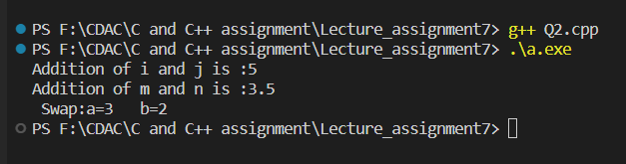
3:Create abstract class Fruit with abstract function taste
Create derived classes for Fruit:Apple,Mango,Orange
Implement abstract method in derived class ,add specific methods like juice(),jam(),pulp() in
respective derived class(as discussed in lect);
create taster program.create fruit basket and invoke method
Use:dynamic_cast,typeid
Q3.h file
#include <iostream>
using namespace std;

class Fruit
{
public:
virtual void taste()
{
cout << "----no taste as such-----" << endl;
}
};
class Apple : public Fruit
{
public:
void jam()
{
cout << "Create Jam From Apple" << endl;
}
void taste()
{
cout << " Apple Taste Sweet " << endl;
}
};
class Mango : public Fruit
{

public:
void pulp()
{
cout << "Mango Pulp get Created..." << endl;
}
void taste()
{
cout << " Mango Taste Sweet " << endl;
}
};
class Orange : public Fruit
{

public:
void juice()
{
cout << "Orange Juice ....." << endl;
}
void taste()
{
cout << " Orange Taste Sweet and sour" << endl;
}
};
Q3.cpp file
#include <iostream>
#include "Q3.h"
#include <typeinfo>
using namespace std;

int main()
{
Fruit f;
f.taste();
cout << "\n"
<< endl;
Apple apple;
apple.taste();
apple.jam();

cout << "\n"
<< endl;
Mango m;
m.pulp();
m.taste();
cout << "\n"
<< endl;

Orange o;
o.juice();
o.taste();

cout << "\n"
<< endl;
Fruit *ptr = &o; // Parent=child
ptr->taste();

Fruit *basket[4];
basket[0] = &f;
basket[1] = &apple;
basket[2] = &m;
basket[3] = &o;
cout << "\n"
<< endl;
for (int i = 0; i < 4; i++)
{
basket[i]->taste();
if (typeid(*basket[i]) == typeid(Orange))
{
cout << "----Orange Is in Basket----" << endl;
Orange *oObj = dynamic_cast<Orange *>(basket[i]);
oObj->juice();

//(dynamic_cast<Orange*>(basket[i]))->juice();
}
if(typeid(*basket[i]) == typeid(Apple)){
cout<<"-------Apple is in basket------"<<endl;
Apple *aobj = dynamic_cast<Apple *>(basket[i]);
aobj->jam();
}
if(typeid(*basket[i]) == typeid(Mango)){
cout<<"-------Mango is in basket-------"<<endl;
Mango *mobj = dynamic_cast<Mango *>(basket[i]);
mobj->pulp();
}
}

return 0;
}
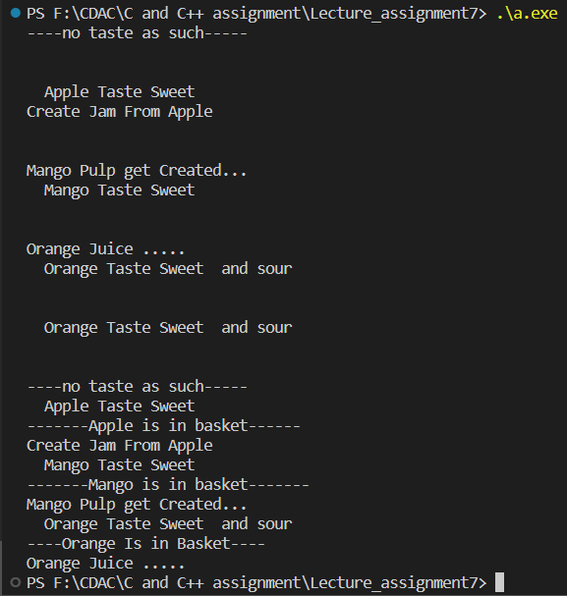
/*1 Write a program to store characters 'A' to 'Z' in the file .
Display the contents of file.*/
#include <iostream>
#include <fstream>
#include <string>
using namespace std;

int main() {
// Open a file for writing
fstream outFile;
outFile.open("characters.txt", ios::in | ios::out | ios::trunc);

if (!outFile) {
cout << "Failed to open the file for writing." << endl;
}

// Write characters 'A' to 'Z' to the file
for (char ch = 'A'; ch <= 'Z'; ++ch) {
outFile << ch << ' ';
}

// Close the file
outFile.close();

// Open the same file for reading
fstream inFile;
inFile.open("characters.txt");

if (!inFile) {
cout << "Failed to open the file for reading." << endl;
}

// Read and display the contents of the file
string str;
cout << "Contents of the file:" << endl;
while (getline(inFile, str)) {
cout << str << ' ';
}

// Close the file
inFile.close();

return 0;
}

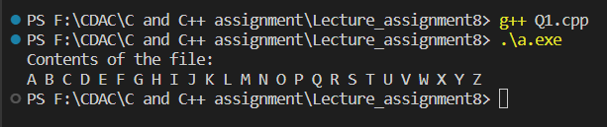
/*2. Create class cEmployee with data members as empno,name and salary.
Accept values from user. Store it in file.
Display the contents from file.
Program should be able to store information of multiple employees.
*/
#include<iostream>
#include<fstream>
#include<string>
using namespace std;

class Employee{
private:
string empno;
string name;
string salary;
public:
Employee(){}

Employee(string empno, string name, string salary){
this->empno = empno;
this->name = name;
this->salary = salary;
}

void storeInfo(fstream &file){
file<<empno<<endl<<name<<endl<<salary;
}

// void display(){
// cout<<"Emp no.: "<<empno<<" Name: "<<name<<" Salary: "<<salary<<endl;
// }
};

int main(){
string empno;
string name;
string salary;
char ch;

fstream outFile("employees.txt", ios::in | ios::out | ios::app);

if(!outFile.is_open()){
cout<<"\nError in opening file....";
}

do
{
cout<<"Enter empno: ";
cin>>empno;
cout<<"\nEnter name: ";
cin>>name;
// getline(cin, name);
cout<<"\nEnter salary: ";
cin>>salary;

Employee emp(empno, name, salary);

emp.storeInfo(outFile);

cout<<"Do you want to hire more employee? Y/N: ";
cin>>ch;

} while (ch == 'Y' || ch == 'y');

outFile.close();

fstream inFile("employees.txt");

if(!inFile){
cout<<"\nError in opening fil..."<<endl;
}

cout<<"\nEmployee info: "<<endl;
string str;
while(getline(inFile, str)){
cout<<str<<endl;
}
inFile.close();
return 0;
}
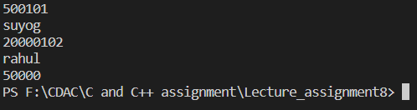

// Write a program to copy the contents of one file and write it into another file and print it.
#include<iostream>
#include<fstream>
#include<string>
using namespace std;

int main(){
fstream source;
source.open("source.txt", ios::in | ios::out | ios::trunc);

if(!source){
cout<<"Failed to open the source file..."<<endl;
}

source<<"Copying this line from source to destination"<<endl;

source.close();
source.open("source.txt");

fstream destination;
destination.open("destination.txt", ios::in | ios::out | ios::trunc);

if(!destination){
cout<<"Failed to open the destination file..."<<endl;
}

char ch;
while(source.get(ch)){
destination.put(ch);
}
source.close();

string str;
cout<<"contents of destination file.."<<endl;
while(getline(destination, str)){
cout<<str<<' ';
}

// while(destination.get(ch)){
// cout << ch << " ";
// }

destination.close();

return 0;
}
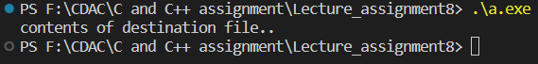
/*Create a C++ program that does the following:
Initializes an empty vector of integers.
Asks the user to enter a series of integers and adds them to the vector until the
user enters a specific sentinel value (e.g., -1).
Prints the elements of the vector.
Calculates and prints the sum and average of the values in the vector.
*/
#include<iostream>
#include<vector>
#include<numeric>
using namespace std;

int main(){
vector<int> myVector;

int n, sum;
double average;

do{
cout<<"\nEnter the number: ";
cin>>n;
if(n>0)
myVector.push_back(n);
else
break;
}while(n>0);

for(int i=0; i<myVector.size(); i++){
cout<<myVector[i]<<endl;
}

sum = accumulate(myVector.begin(), myVector.end(), 0);

average = (double)(sum/myVector.size());

cout<<"Sum: "<<sum<<" average: "<<average<<endl;

return 0;
}
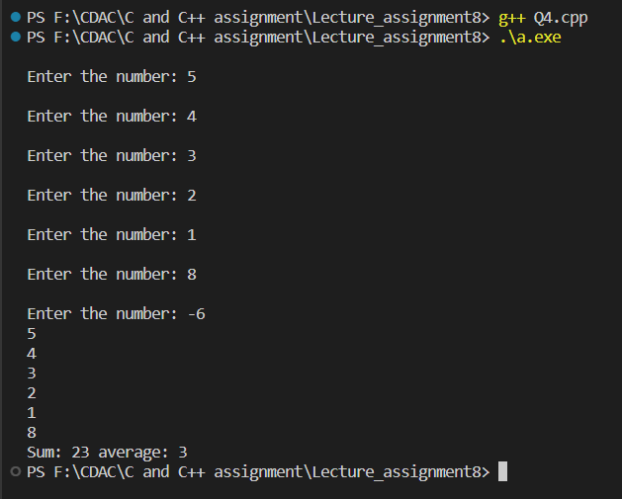
/*5:Defines a Student class with attributes like name, age, and grade.
Initializes a vector of Student objects.
Allows the user to add new students to the vector with their name, age, and grade.
Prints the list of students.
*/
#include<iostream>
#include<vector>
#include<string>
using namespace std;

class Student{
private:
string name;
int age;
char grade;
public:
Student(){};

Student(string name, int age, char grade){
this->name = name;
this->age = age;
this->grade = grade;
}

void display(){
cout<<"Name: "<<name<<", age: "<<age<<" ,grade: "<<grade<<endl;
}
};

int main(){
int age;
string name;
char grade, choice;

vector<Student> myVector;

do{
cout<<"Enter name: ";
cin>>name;
cout<<"\nEnter age: ";
cin>>age;
cout<<"\nEnter grade: ";
cin>>grade;

Student st(name, age, grade);

myVector.push_back(st);

cout<<"\nAdd new student?: Y/N";
cin>>choice;

}while(choice == 'Y' || choice == 'y');

for(int i=0; i<myVector.size(); i++){
myVector[i].display();
}

return 0;
}
